AWK COMMAND IN LINUX:

# who

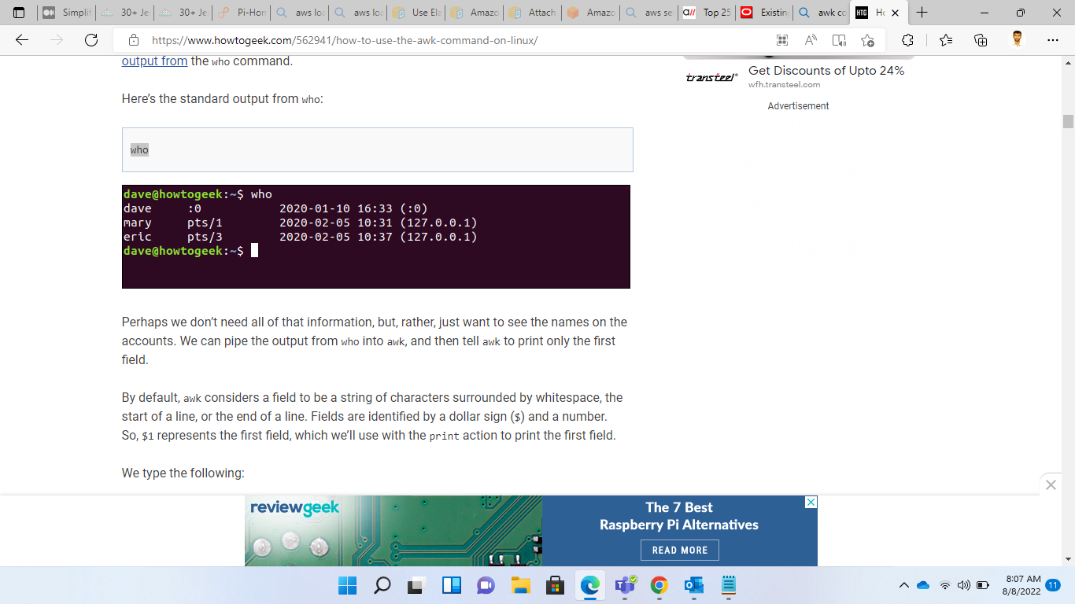

# who | awk '{print $1}'

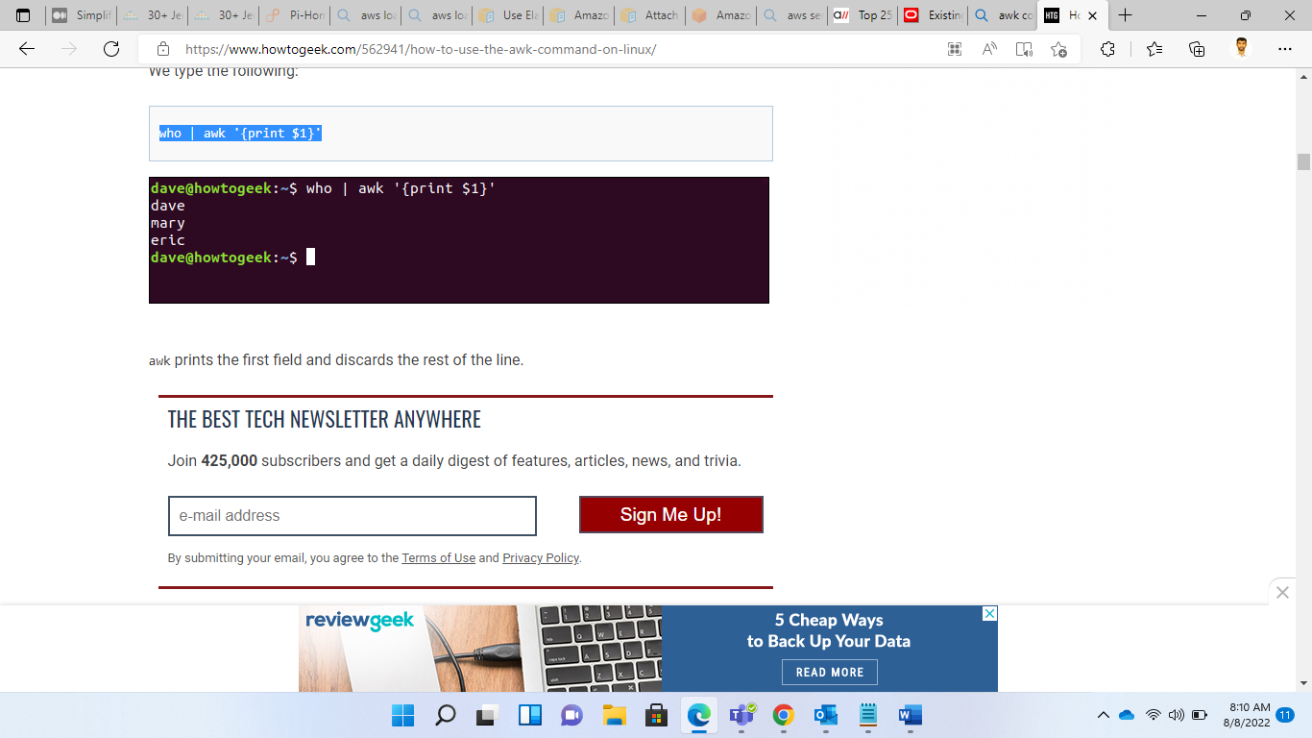

[How to Use the awk Command on Linux (howtogeek.com)](https://www.howtogeek.com/562941/how-to-use-the-awk-command-on-linux/)